**Add custom page layout to your site**

## Step 1: Create a web template and write the Liquid template code

First, we'll create our web template and write the Liquid template code. We're likely to reuse some common elements of this template in future templates. So, we'll create a common base template that we'll extend with our specific template. Our base template will provide breadcrumb links, our page title/header, and define our two-column layout.

1. Go to [Power Pages](https://make.powerpages.microsoft.com/).
2. In the **design studio**, choose **...** and then select **Portal Management**. You'll need to use the Portal Management app to create a web template record and enter in your custom code.

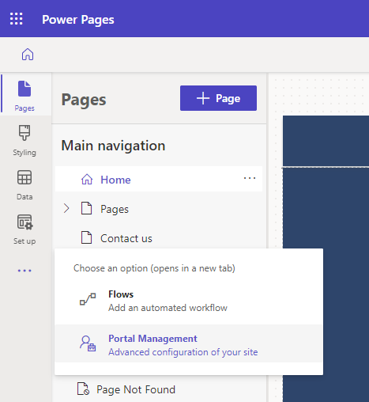

1. In the **Portal Management app**, scroll to the **Content** section and select **Web Templates**.
2. From **Active Web Templates** screen, select **New**.
3. Name the web template to **Two Column Layout**.

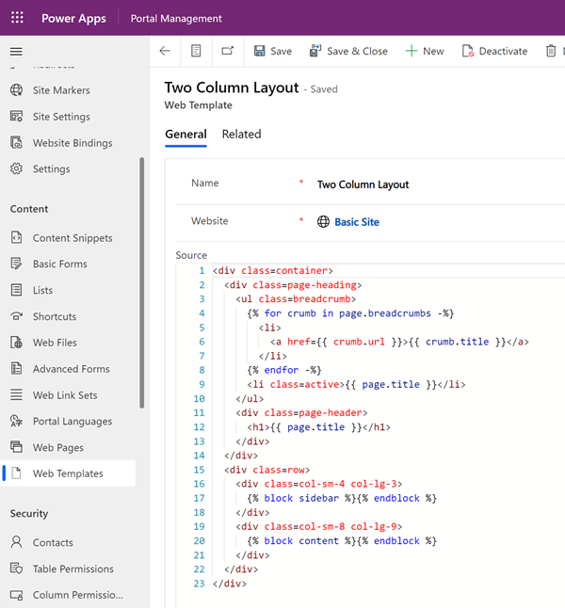

1. Paste the following code into the **Source** field.

### Two Column Layout (Web Template)

<div class=container>

<div class=page-heading>

<ul class=breadcrumb>

{% for crumb in page.breadcrumbs -%}

<li>

<a href={{ crumb.url }}>{{ crumb.title }}</a>

</li>

{% endfor -%}

<li class=active>{{ page.title }}</li>

</ul>

<div class=page-header>

<h1>{{ page.title }}</h1>

</div>

</div>

<div class=row>

<div class=col-sm-4 col-lg-3>

{% block sidebar %}{% endblock %}

</div>

<div class=col-sm-8 col-lg-9>

{% block content %}{% endblock %}

</div>

</div>

</div>

1. Select **Save**.

## Step 2: Create a new web template that extends our base layout template

We're going to create a web template that will read the navigation record from the associated web page (see below). We'll also extend the base template we created in the previous step. Web templates can be used as reusable components when creating advanced sites.

1. In the **Portal Management app**, scroll to the **Content** section and select **Web Templates**.
2. From the **Active Web Templates** screen, select **New**.
3. Name the web template to **Weblinks Left Navigation**.

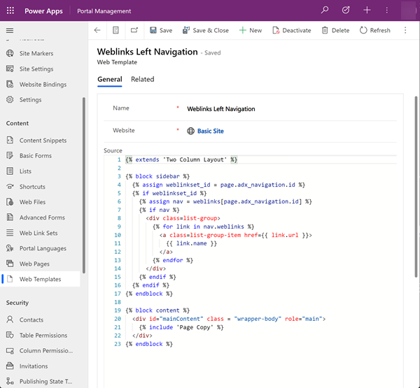

### Weblinks Left Navigation (Web Template)

Note how the code uses the Liquid extends keyword to incorporate the base layout template.

{% extends 'Two Column Layout' %}

{% block sidebar %}

{% assign weblinkset_id = page.adx_navigation.id %}

{% if weblinkset_id %}

{% assign nav = weblinks[page.adx_navigation.id] %}

{% if nav %}

<div class=list-group>

{% for link in nav.weblinks %}

<a class=list-group-item href={{ link.url }}>

{{ link.name }}

</a>

{% endfor %}

</div>

{% endif %}

{% endif %}

{% endblock %}

{% block content %}

<div id="mainContent" class = "wrapper-body" role="main">

{% include 'Page Copy' %}

</div>

{% endblock %}

## Step 3: Create a new page template based on the web template

In this step, we'll create a new page template that is based on the web template we created in the previous step. The page template is required for our custom page layout to be an option you can select when creating a new web page.

1. In the **Portal Management app**, scroll to the **Website** section and select **Page Templates**.
2. From **Active Page Templates** screen, select **New**.
3. Fill in the fields.

| **Field** | **Value** |
| --- | --- |
| Name | Type in a name. |
| Website | Select the web site to which the theme will be applied. Put your cursor in the field and hit enter on your keyboard to display a list of available options. |
| Type | Choose **Web Template** |
| Web Template | Select **Web Links Left Navigation** (or whatever you named your web template). |
| Use Website Header and Footer | Checked. |
| Is Default | Unchecked. |
| Table Name | None selected. |
| Description | A description of your page template. |

1. 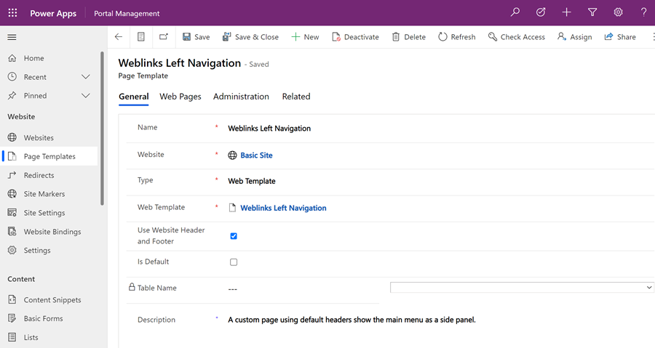
2. Select **Save**.

## Step 4: Create a web page to display content

1. In the **design studio**, select **Sync**. This will bring updates made in the Portal Management app to the design studio.
2. In the **Pages** workspace, select **+ Page**.
3. In the **Add a page** dialog;
   1. Enter in **Page name**
   2. From the **Custom layouts**, select your custom page layout.
   3. Select **Add**.

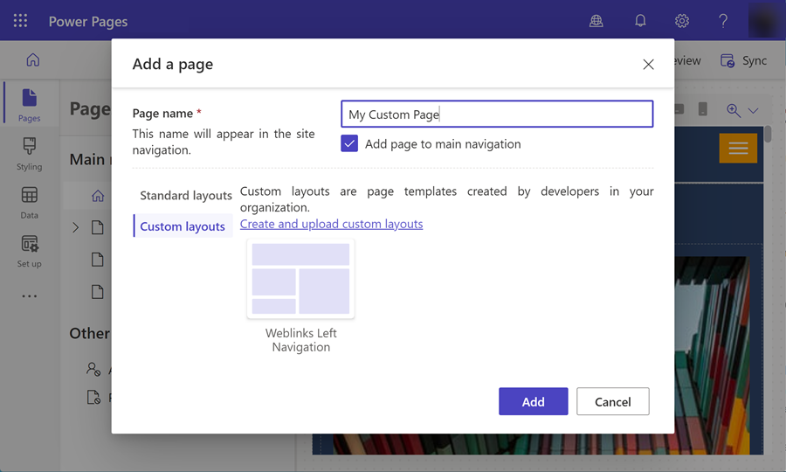

1. Add any more content to the editable sections of the page.

### Additional page configuration

In this example, we'll need to link the navigation record to the content page in order for our custom code to render the menu on the left navigation.

1. In the **design studio**, choose **...** and then select **Portal Management**. You'll use the Portal Management app to add additional configuration to your page.
2. In the **Portal Management app**, scroll to the **Content** section and select **Web Pages**.
3. Locate and open the page you created previously in the **Pages** workspace. This will open the root webpage. We'll need to make our changes in the related localized content page.
4. Scroll down and in the **Localized Content** section, select the localized content web page.

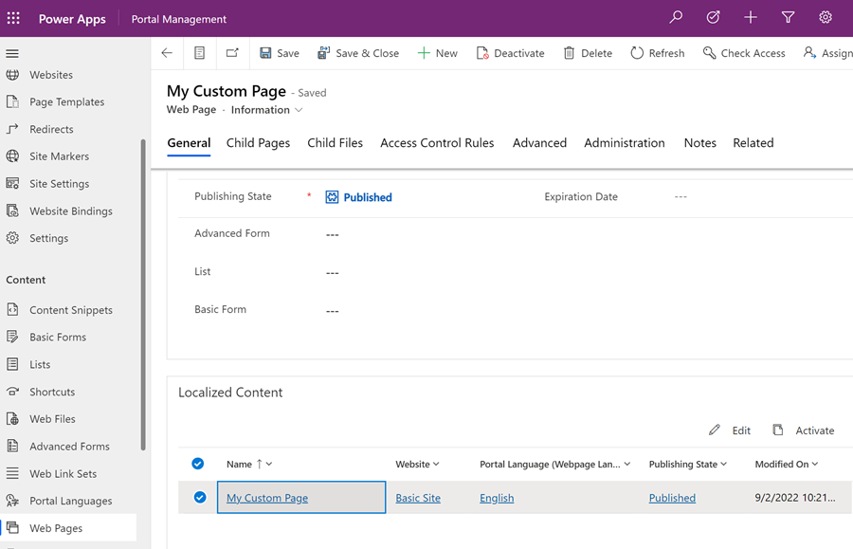

**Note**

If you have multiple languages provisioned, you will need to update each localized page.

1. Go to the **Miscellaneous** section and select the web link set you want to display in the **Navigation** field.

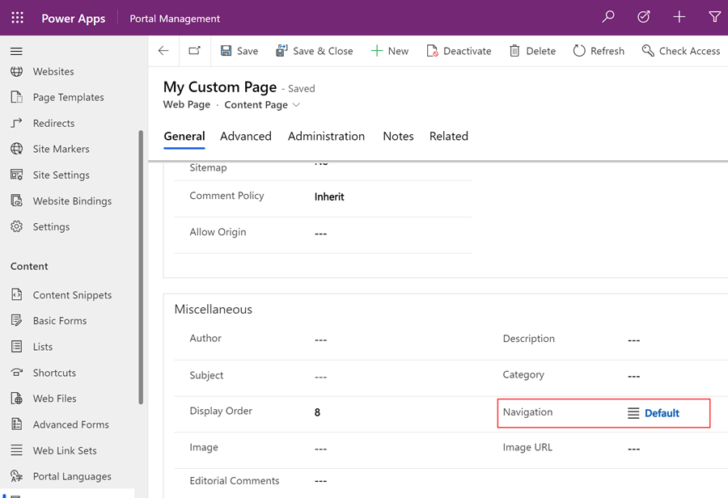

1. Save your changes, and return to the **design studio**.
2. Select **Preview** and then **Desktop** to view your custom page with the side navigation implemented.

